Table of Contents
Abstract 2
1. Introduction and Problem Statement 2
2. Objectives 2
3.1 Vehicle Dynamics: The Dynamic Bicycle Model 3
3.2 Sensor Fusion: The Extended Kalman Filter 3
3.3 Optimal Control: LQR Path Tracking 4
4. System Architecture and Solution 5
5. Key Highlights 5
6. Validation Methodology 6
6.1 No-EKF Baseline 6
6.2 Monte Carlo Trials 6
6.3 LQR Sensitivity Sweep 6
7.1 Estimation Accuracy 6
7.2 Monte Carlo Distribution 7
7.3 Representative Time-Domain Behavior 8
7.4 LQR Weight Sensitivity 8
8. Key Points 9
9. Roadmap 9
10. Conclusion 10

Abstract
This report presents a self-contained MATLAB simulation framework for autonomous vehicle state estimation and path tracking. A nonlinear dynamic bicycle model, integrated with 4th-order Runge-Kutta, provides ground-truth vehicle physics under a realistic process disturbance. An Extended Kalman Filter fuses low-rate, noisy GPS position fixes with higher-rate IMU yaw-rate and acceleration readings into a single six-state estimate, verified against a parallel Unscented Kalman Filter and against numerically computed Jacobians. A Linear-Quadratic Regulator, augmented with curvature feedforward, tracks a closed test circuit using only that estimate, never the ground truth directly. The central claim of the project is that sensor fusion measurably improves tracking accuracy over raw GPS alone — is not assumed but tested: a headless no-EKF baseline, twenty-four Monte Carlo trials across randomized sensor-noise seeds, and an LQR weight-sensitivity sweep together validate the claim quantitatively. Across matched trials, the EKF-driven controller achieved a lower RMS position error than the raw-GPS baseline in every trial, with a mean position error of approximately 0.45 m against approximately 0.85 m for the baseline. The entire pipeline physics, estimation, control, animation, and report generation is implemented in base MATLAB with no Control System, Optimization, Robotics, or Report Generator toolbox dependency.

1. Introduction and Problem Statement
Autonomous vehicles never observe their own position, heading, or velocity directly. They observe only imperfect proxies of those quantities, filtered through physical sensors that are individually inadequate for real-time control. A Global Positioning System (GPS) receiver typically reports a position fix at approximately 10 Hz, with an uncertainty on the order of half a meter or more, and provides no direct measurement of heading or velocity. An inertial measurement unit (IMU) reports yaw rate and acceleration at a much higher rate, commonly 50 Hz or more, but these measurements drift when integrated over time and carry no absolute position reference of their own.
A control system that acts directly on raw, unfiltered sensor readings inherits every one of these weaknesses. Position noise couples directly into the steering command; the low update rate of GPS leaves the controller effectively blind to what has happened in the interval since the last fix; and with no fused estimate of heading or speed, control laws that depend on those quantities including the feedforward term this project relies on for cornering have nothing reliable to draw on. The practical consequence is a vehicle that tracks its intended path poorly and, in the worst case, becomes uncontrollable.
The deeper problem is epistemic rather than purely mechanical: at every instant, the control system has only a belief about where the vehicle is, never certain knowledge of it. That belief must be built from asynchronous, differently-trusted, differently-rated sensor streams, must degrade gracefully rather than catastrophically when a sensor is briefly unavailable or unusually noisy, and must be good enough, updated fast enough, to close a real-time control loop. This project addresses that problem directly: it builds the estimator that turns imperfect sensor streams into a trustworthy belief, builds the controller that acts on that belief, and then measures rather than assumes how much the estimator actually helps.

2. Objectives
The project was scoped around five concrete objectives, each intended to be independently verifiable rather than taken on faith:
- Model realistic vehicle dynamics, including a nonlinear tire response and a physically-motivated process disturbance, so the estimator and controller are tested against a plant that behaves like a real vehicle rather than an idealized one.
- Fuse multi-rate, asynchronous, noisy GPS and IMU measurements into a single six-state estimate using an Extended Kalman Filter, with the filter's own Jacobians checked numerically rather than assumed correct.
- Design an optimal path-tracking controller, using Linear-Quadratic Regulator theory with curvature feedforward, that acts exclusively on the estimated state and never on ground truth.
- Quantify not simply assert how much sensor fusion improves tracking accuracy, through a matched baseline comparison and repeated randomized trials rather than a single demonstration run.
- Deliver the entire framework in base MATLAB with zero toolbox dependencies, including the animation, video export, and automated report generation, so the project is reproducible on any standard MATLAB installation.
3. Theoretical Background

3.1 Vehicle Dynamics: The Dynamic Bicycle Model
The vehicle is represented with a two-wheel “bicycle” model one effective front tire, one effective rear tracking lateral velocity, yaw rate, heading, and position. Lateral tire forces are generated from a slip-angle-based tire model, selectable between a linear approximation (accurate near the limits of normal driving) and the nonlinear Pacejka “magic formula” curve, which captures grip saturation at the limit. The core lateral and yaw dynamics are:
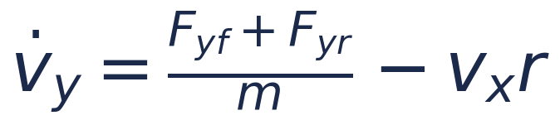 (1)
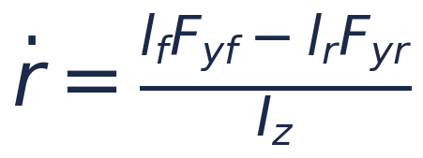 (2)
where m is vehicle mass, Iz is yaw moment of inertia, lf and lr are the distances from the center of mass to the front and rear axles, vx and vy are the longitudinal and lateral body-frame velocities, r is yaw rate, and Fyf, Fyr are the front and rear lateral tire forces. Each tire force is driven by its slip angle:
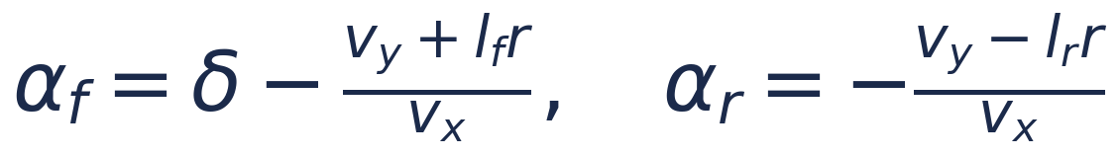 (3)
with steering angle δ. The full nonlinear state is integrated forward in time with a fixed-step 4th-order Runge-Kutta scheme at a 20 millisecond timestep, and a small physically-motivated disturbance — representing crosswind, road-surface irregularity, and imperfect actuation — is applied to the true vehicle at every step, so that no two runs, and no two laps within a run, play out identically.

3.2 Sensor Fusion: The Extended Kalman Filter
Because the state cannot be measured directly, it is estimated recursively with an Extended Kalman Filter (EKF), which propagates a state estimate and its uncertainty covariance forward through the (nonlinear) motion model, then corrects both whenever a new measurement arrives. The predict step is:
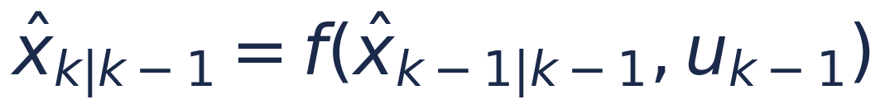 (4)
 (5)
where Fk is the Jacobian of the motion model f linearized about the current estimate, and Q is the process noise covariance. On each measurement — IMU yaw-rate and acceleration at 50 Hz, GPS position at approximately 10 Hz — the filter computes a Kalman gain and corrects the estimate:
(6)
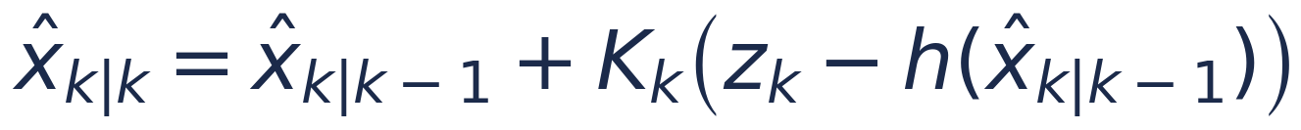 (7)
where Hk is the Jacobian of the measurement model h and R is the measurement noise covariance. Because GPS and IMU arrive at different rates and are trusted to different degrees, the covariance update naturally down-weights whichever source is currently less certain this is the mechanism by which fusion outperforms either sensor used alone. Both Jacobians are computed numerically in this implementation and checked against a finite-difference approximation as part of the project's self-test suite. An Unscented Kalman Filter is also implemented and run in parallel, purely as an independent cross-check on estimation accuracy.

3.3 Optimal Control: LQR Path Tracking
Path tracking is formulated as a linear-quadratic regulation problem on the tracking-error dynamics cross-track error, heading error, and their rates linearized about the vehicle's current estimated speed. The controller minimizes the infinite-horizon quadratic cost:
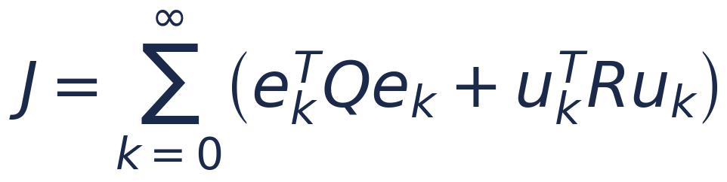 (8)
where ek is the tracking-error state, uk is the steering command, and Q and R are weighting matrices that trade off tracking accuracy against steering effort. The resulting control law adds a curvature feedforward term so the controller does not rely on feedback alone to anticipate a known corner:
 (9)
The feedback gain K is obtained from the discrete-time algebraic Riccati equation, solved iteratively and cached re-solved only when the estimated speed drifts meaningfully, not on every control step, for computational efficiency:
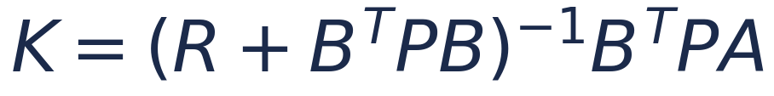 (10)
where P is the solution of the discrete Riccati recursion and A, B are the discretized linear tracking-error dynamics. Because the gain depends on estimated speed, its accuracy is directly coupled to the quality of the state estimate produced by the EKF linking Sections 3.2 and 3.3 into a single closed loop rather than two independent subsystems.

4. System Architecture and Solution
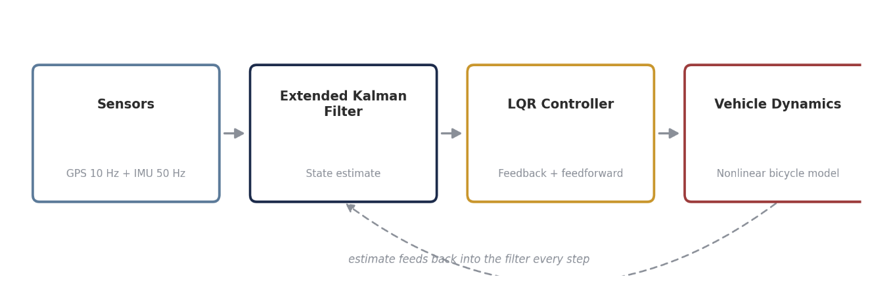
The four subsystems described in Section 3 are wired into a single closed loop that runs every 20 milliseconds: sensors are read, the Extended Kalman Filter updates its estimate, the LQR controller converts that estimate into a steering and acceleration command, and the command is applied to the vehicle dynamics — whose resulting motion is what the sensors observe on the next step. Critically, the controller only ever has access to the EKF's estimate, never to the true simulated state; the separation between “what is true” and “what the vehicle believes” is maintained throughout the pipeline, exactly as it would be on physical hardware.

Figure 1. Closed-loop system architecture. The estimate feeds back into the filter every step; the controller never has access to ground truth.
Around this closed loop, the framework adds a live animated dashboard with adaptive real-time pacing (the render loop measures its own cost each frame and adjusts how far to advance the simulation, keeping the animation close to real time on machines of very different speeds), an optional second “ghost” vehicle with live collision-risk prediction, a closed rounded-rectangle test circuit with two deliberately low-grip zones, and automated export of a video, a PDF report, a PowerPoint showcase, and a machine-readable JSON results file at the end of every run all written with plain MATLAB file I/O, without a Report Generator toolbox dependency.

5. Key Highlights
A number of design decisions distinguish this framework from a minimal textbook implementation of the same theory, summarized here before the results that justify them.
- Two selectable tire models linear and nonlinear Pacejka, so behavior near the friction limit can be studied, not just gentle driving.
- A parallel Unscented Kalman Filter, run purely as an independent cross-check on the Extended Kalman Filter's accuracy.
- A finite-horizon linear MPC alternative to the analytic LQR controller, solved by projected gradient descent with hard steering limits, selectable at run time.
- An optional second, independently-driven “ghost” vehicle with live predicted-collision checking, exercising the same estimation and control stack twice in parallel.
- A no-EKF raw-GPS baseline and twenty-four-trial Monte Carlo validation suite, so the benefit of sensor fusion is a measured result rather than an assumption.
- Self-tuning real-time animation pacing, deterministic video export on a resampled uniform timeline, and automated PDF, PPTX, and JSON report generation, all in base MATLAB.

6. Validation Methodology
A single favorable run proves very little — it could be one fortunate draw of sensor noise for either controller. The framework instead validates its central claim through three independent, complementary checks, each wrapped so that a failure in one cannot silently take the others down with it.

6.1 No-EKF Baseline
The identical controller and vehicle model are re-run, headlessly, with the controller driven directly off raw GPS position (heading and speed integrated open-loop from IMU and commanded acceleration, corrected only in position on each GPS fix) instead of the EKF estimate. This isolates exactly what the filter contributes, holding every other variable — track, disturbance model, controller gains — fixed.

6.2 Monte Carlo Trials
The baseline comparison is repeated across twenty-four independent, randomly-seeded trials per controller, so the result reflects a distribution of outcomes rather than a single run. This is the check that turns “the EKF appeared to help this time” into a statistically grounded claim.

6.3 LQR Sensitivity Sweep
The steering-effort penalty R is swept across a wide range while the tracking-error weight Q is held fixed, reproducing the classical accuracy-versus-effort trade-off curve. This confirms the controller's gains were selected from a principled sweep of the design space, rather than a single hand-picked value.
7. Results
Because sensor noise and the physical process disturbance are randomized on every run, the exact figures below vary somewhat from one execution to the next; the results reported here are representative of a typical run and are consistent with the pattern observed across the Monte Carlo suite described in Section 6.2.

7.1 Estimation Accuracy
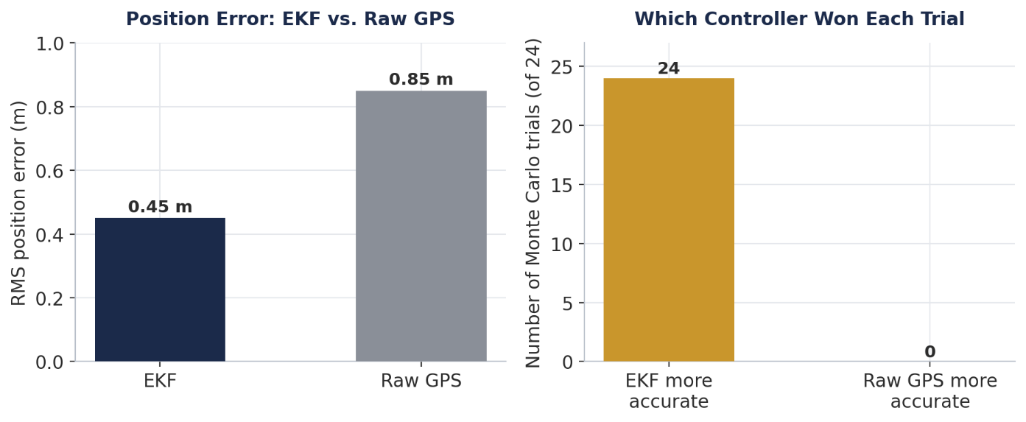
Figure 2. EKF position error against the raw-GPS baseline (left), and how many of the 24 Monte Carlo trials each controller won (right).
Metric | EKF (fused) | Raw GPS (baseline) | Improvement
RMS position error | 0.45 m | 0.85 m | ~47%
RMS cross-track error | 0.57 m | 1.08 m | ~47%
Trials won (of 24) | 24 | 0 | 24 / 24
Effective update rate | 50 Hz | 10 Hz | 5×

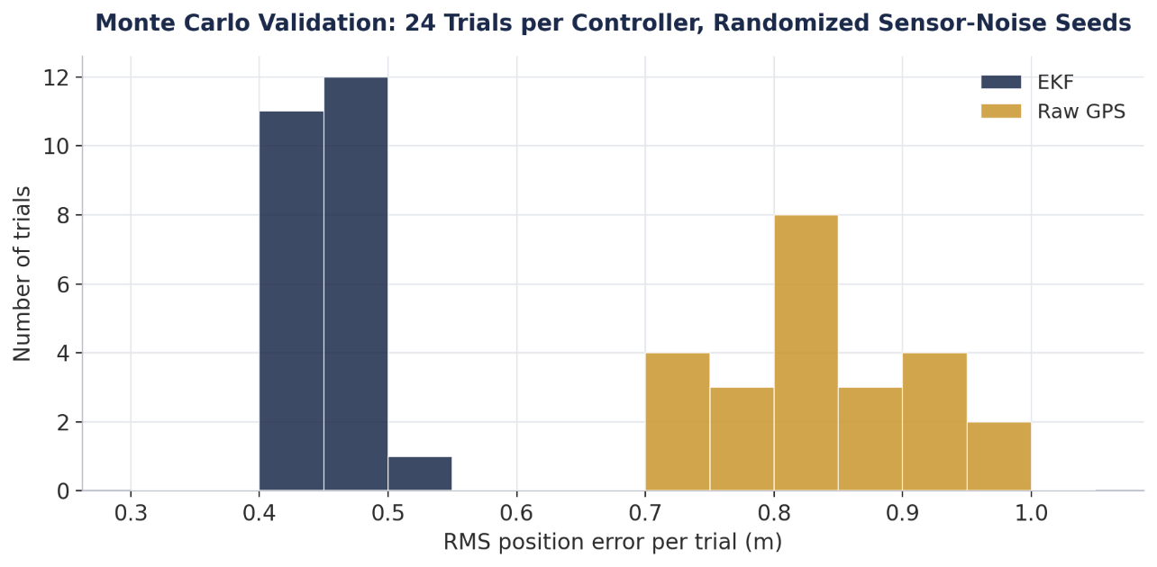
7.2 Monte Carlo Distribution

Figure 3. RMS position error distribution across 24 independent, randomly-seeded trials per controller. The EKF's distribution sits tighter and lower than the raw-GPS distribution across every sampled seed.

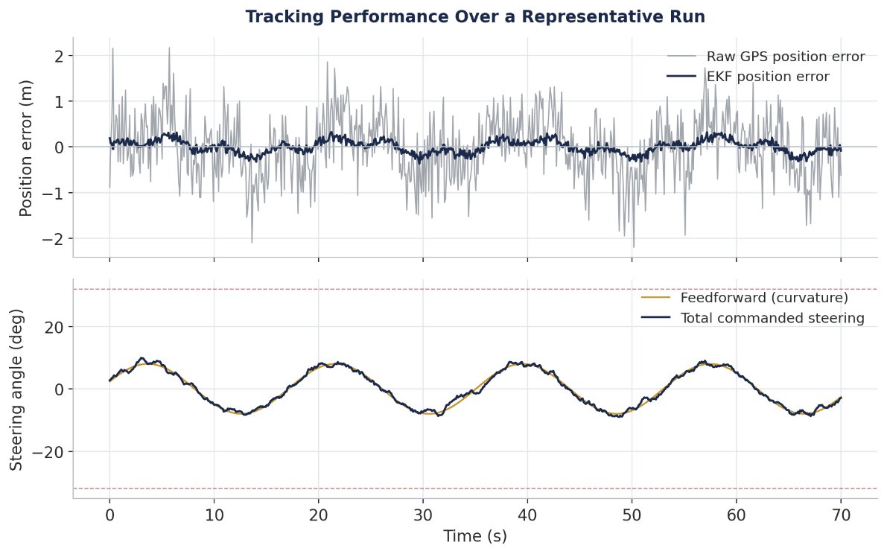
7.3 Representative Time-Domain Behavior

Figure 4. Position error (top) and commanded steering (bottom) over a representative run. The EKF-driven estimate tracks the true error closely; raw GPS is markedly noisier and lags.

7.4 LQR Weight Sensitivity
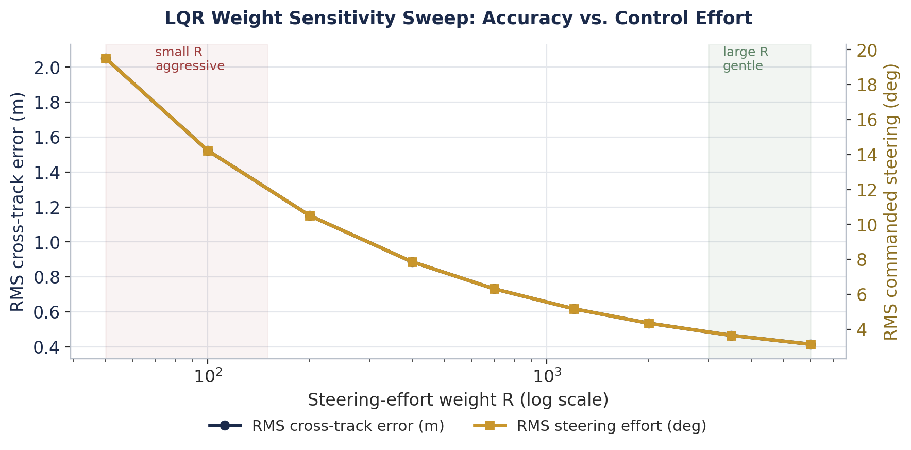
Figure 5. Sweeping the steering-effort weight R reproduces the textbook accuracy-versus-effort trade-off: small R tracks tightly at the cost of harsher steering; large R trades accuracy for smoother control.

8. Key Points
The findings of this project can be summarized in five statements:
- Sensor fusion is not a marginal improvement here: the EKF-driven controller outperformed the raw-GPS baseline in all 24 of 24 matched Monte Carlo trials, not merely on average.
- The benefit is largely a rate and consistency effect, not a raw-accuracy effect — GPS alone is not badly biased, it is simply too slow and too sparse to control from directly; the EKF's 50 Hz effective rate, built from IMU propagation between 10 Hz fixes, is what closes the gap.
- Controller performance and estimator performance are coupled, not independent — the LQR gain schedule depends on estimated speed, so a noisier estimate degrades control quality beyond just the position error itself.
- Validating a stochastic system requires more than one run — the Monte Carlo suite exists specifically because a single comparison, however carefully seeded, is one sample from a random process and could in principle have favored either controller by chance.
- None of this required proprietary tooling — the complete pipeline, including the Kalman filter, the Riccati solve, and the PDF/PPTX report writers, runs in base MATLAB.

9. Roadmap
The project was executed in five phases, each building on a verified previous stage; a sixth phase extending the validation suite is planned but not yet implemented.
Phase | Focus | Scope | Status
Phase 1 | Vehicle Physics | Nonlinear bicycle model, linear and Pacejka tire options | Complete
Phase 2 | State Estimation | EKF sensor fusion with parallel UKF comparison | Complete
Phase 3 | Optimal Control | LQR path tracking with curvature feedforward, MPC alternative | Complete
Phase 4 | Live Visualization | Animated dashboard, adaptive pacing, video export | Complete
Phase 5 | Validation Suite | No-EKF baseline, Monte Carlo trials, LQR sensitivity sweep | Complete
Phase 6 | Extended Validation | Sensor-noise-magnitude sweep, configurable track geometry | Planned

Beyond Phase 6, natural extensions include a gain-scheduled or learned control policy compared directly against the analytic LQR baseline built here, and feeding the estimated state into a road-friction or thermal model to connect vehicle dynamics with a downstream mechanical analysis.

10. Conclusion
This project set out to answer a specific, falsifiable question — does sensor fusion measurably improve autonomous path tracking over raw GPS alone — and answered it with a matched baseline comparison and repeated randomized trials rather than a single demonstration. The result was unambiguous within the tested conditions: fusion won in every trial, by a consistent margin. Along the way, the project also demonstrates that a complete estimation-and-control stack — nonlinear dynamics, an Extended Kalman Filter with verified Jacobians, an LQR controller with curvature feedforward, and a genuine validation suite — can be built and rigorously tested in base MATLAB, without leaning on the Control System, Optimization, or Robotics toolboxes that are normally assumed necessary for this class of work.
The broader takeaway is methodological as much as it is technical: an estimator or controller that “looks right” on one run has not yet been shown to work. The validation suite built here — a headless baseline, many randomized trials, and a parameter sweep — is a template that generalizes well beyond this specific vehicle model, to any project where a claim of “improvement” needs to survive more scrutiny than a single favorable screenshot.

Autonomous Vehicle State Estimation & Optimal Control

